- cal – shows the calender

- whoami – shows which user is logged in

- users – shows the number of users

- who – which user is logged in at what time and tty7 (user number)

- exit – exit from the terminal (close the terminal)

- halt – Brings the system down immediately
- init 0 – Powers off the system using predefined scripts to synchronize and clean up the system prior to shutting down

- init 6 – Reboots the system by shutting it down completely and then restarting it

- poweroff – Shuts down the system by powering off

- reboot – Reboots the system

- shutdown – Shuts down the system

- https://www.digitalocean.com/community/tutorials/how-to-create-a-sudo-user-on-ubuntu-quickstart

------------------------------------------------------------------------------------------------------------------------

Listing Files:

- ls
listing all files and directories in the current directory except hidden files and directories.

- ls -l
listing all files and directories with more detail information.

  - First Column − Represents the file type and the permission given on the file. Below is the description of all type of files.
  - Second Column − Represents the number of memory blocks taken by the file or directory.
  - Third Column − Represents the owner of the file. This is the Unix user who created this file.
  - Fourth Column − Represents the group of the owner. Every Unix user will have an associated group.
  - Fifth Column − Represents the file size in bytes.
  - Sixth Column − Represents the date and the time when this file was created or modified for the last time.
  - Seventh Column − Represents the file or the directory name.
Use vi editor:
$ vi filename
Press the key “i” to come into the edit mode.
Press the key “Esc” to come out of the edit mode.
- “l” key to move to the right side.
- “h” key to move to the left side.
- “k” key to move upside in the file.
- “j” key to move downside in the file.
Press two keys “Shift + ZZ” together to come out of the file completely.
------------------------------------------------------------------------------------------------------------------------
$ cat filename
This command will shows the contents inside the file.

$ cat -b filename
This command will shows the contents inside the file with the line number.
------------------------------------------------------------------------------------------------------------------------
$ wc filename1 filename2 ...
We can enter single or multiple files here.
This command will shows the count of the total number of lines, words, and characters contained in a file.
- First Column − Represents the total number of lines in the file.
- Second Column − Represents the total number of words in the file.
- Third Column − Represents the total number of bytes in the file. This is the actual size of the file.
- Fourth Column − Represents the file name.
------------------------------------------------------------------------------------------------------------------------

Linux Directory Structure:
‘/’ is the root directory and main directory.
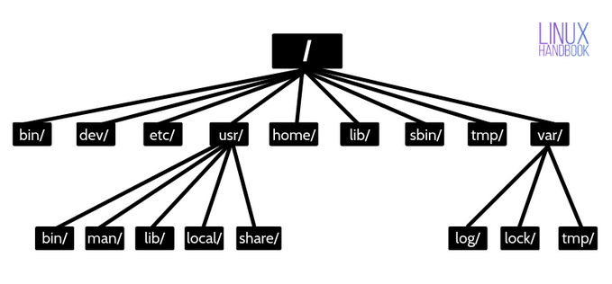
- /bin – it contains the executable files of many basic shell commands like ls, cp, cd etc. Mostly the programs are in binary format here and accessible by all the users in the Linux system.

- /dev – This directory only contains special files, including those relating to the devices. These are virtual files, not physically on the disk.
Some interesting examples of these files are:
- /dev/null: can be sent to destroy any file or string
- /dev/zero: contains an infinite sequence of 0
- /dev/random: contains an infinite sequence of random values

- /etc – The /etc directory contains the core configuration files of the system, use primarily by the administrator and services, such as the password file and networking files. If you need to make changes in system configuration (for example changing the hostname), this is where you’ll find the respective files.

- /usr – it contains user binaries and program data.
In ‘/usr’ go all the executable files, libraries, source of most of the system programs. For this reason, most of the files contained there in is read-only (for the normal user)
  - ‘/usr/bin’ contains basic user commands
  - ‘/usr/sbin’ contains additional commands for the administrator
  - ‘/usr/lib’ contains the system libraries
  - ‘/usr/share’ contains documentation or common to all libraries, for example ‘/usr/share/man’ contains the text of the manpage

